1. Hasil Praktikum1 (pendeskripsian variabel)

* Sourcecode

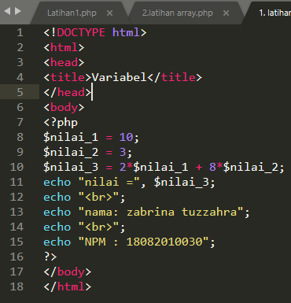

* Screenshoot

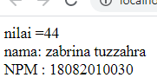

* Analisa

1. Hasil Praktikum2 (Penggunaan Array menggunakan PHP)

* Sourcecode

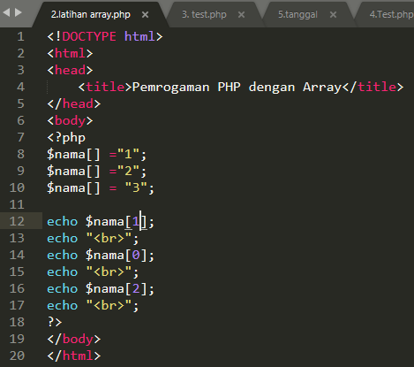

* Screenshoot

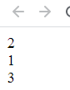

* Analisa

1. Hasil Praktikum3 (Mengkonversi tipe Data)

* Sourcecode

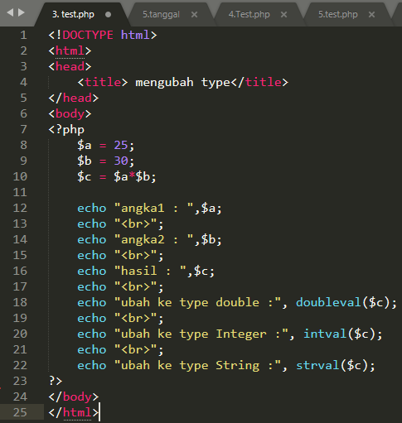

* Screenshoot

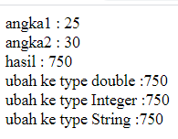

* Analisa

1. Hasil Praktikum4 (Menampilkan Tanggalan)

* Sourcecode

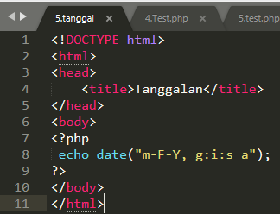

* Screenshoot



* Analisa

1. Hasil Praktikum5 (Menggunakan Variabel POST)

* Sourcecode

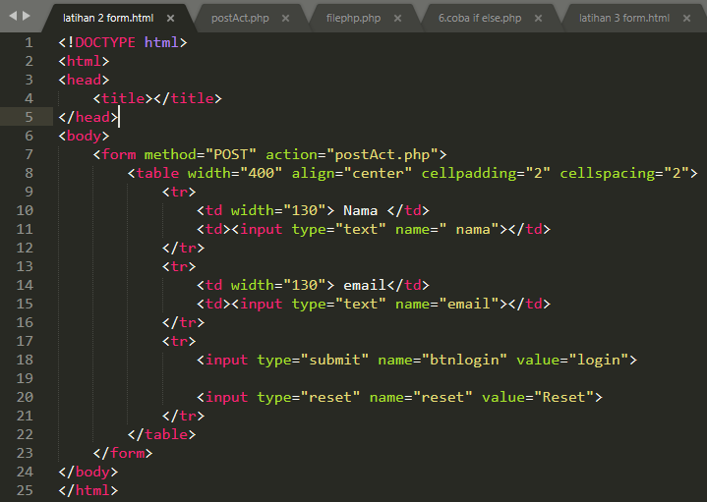

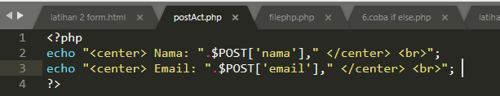

* Screenshoot

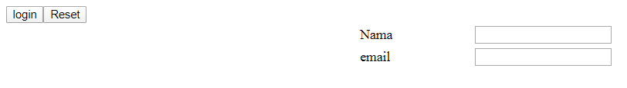

* Analisa

1. Hasil Praktikum6 (Penggunaan Include)

* Sourcecode

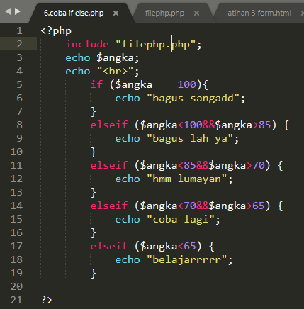

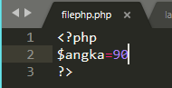

* Screenshoot



* Analisa

1. Hasil Praktikum7 (redirect Halaman)

* Sourcecode

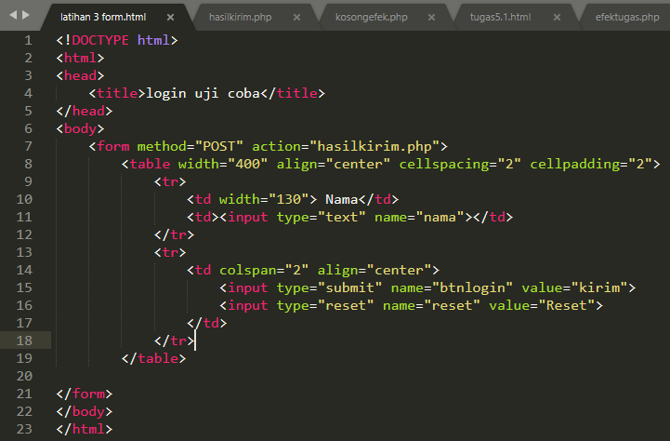

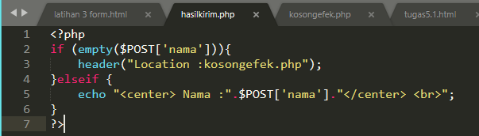

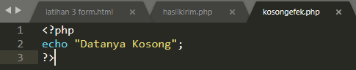

* Screenshoot

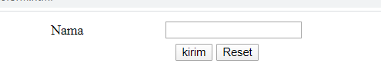

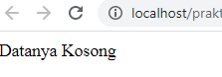

* Analisa

1. Hasil Praktikum9 (Tugas 1 & 2)

* Sourcecode

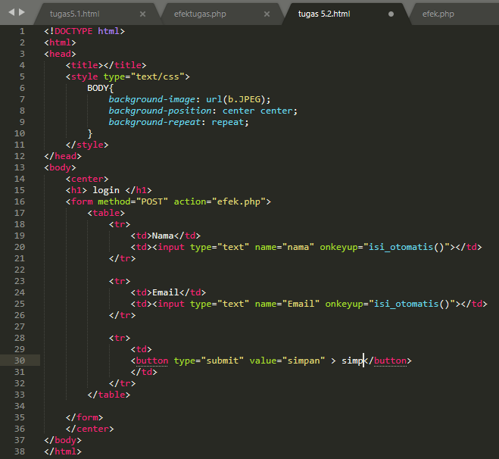

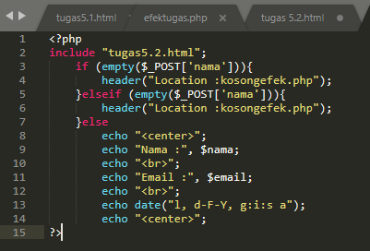

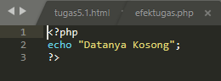

* Screenshoot

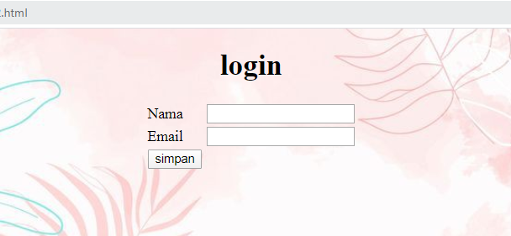

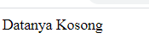

* Analisa

1. Hasil Praktikum10 (Tugas 3)

* Sourcecode

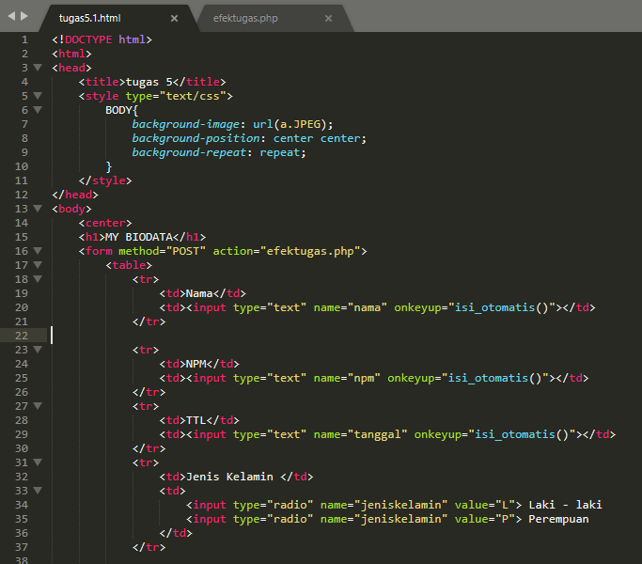

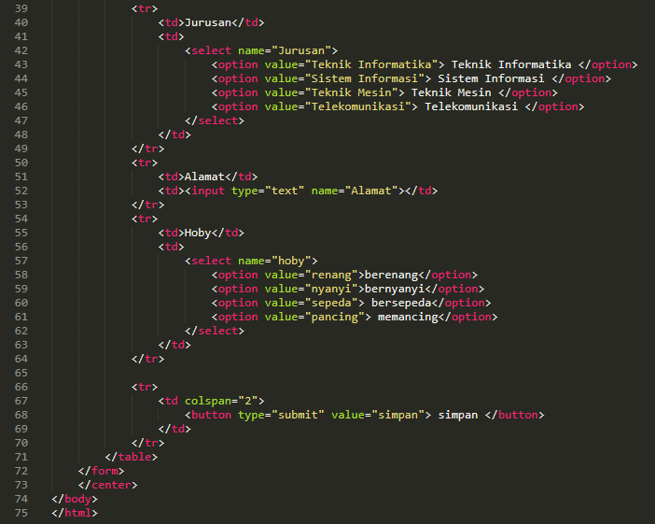

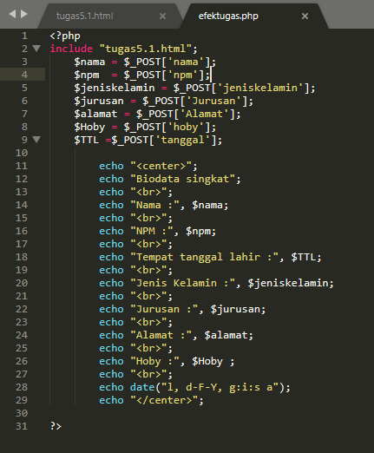

* Screenshoot

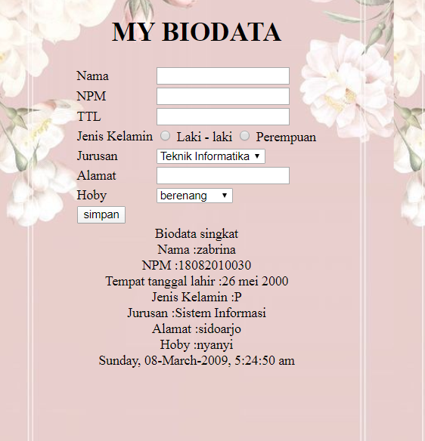

* Analisa